**Lab Report No : 02**

**Lab Report Name : Basic Command of Linux Operating System**

**Question : What is Linux command?**

**Answer :**Linux is a Unix-Like operating system. All the Linux/Unix commands are run in the terminal provided by the Linux system. This terminal is just like command prompt of Windows OS. Linux/Unix commands are case-sensitive. The terminal can be used to accomplish all Administrative tasks. This includes package installation, file manipulation, and user management. Linux terminal is user-interactive. The terminal outputs the results of commands which are specified by the user itself.

**Question: Describe the operation of Linux basic command(screenshot).**

**Answer :**The operation of basic Linux command is given below :

1. ls : ls command is used for listing contents of a directory. It works as dir command.

Example :

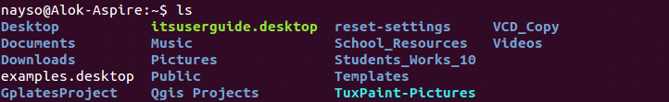

1. pwd :pwd command displays the name of current/working directory as below.

Example :



1. chmod: chmod command is used to change/update file access permissions like this .

Example:

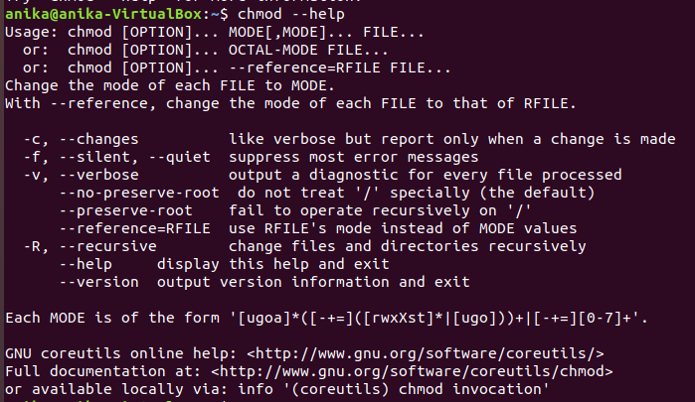

1. df: df command is used to show file system disk space usage as follows.

Example :

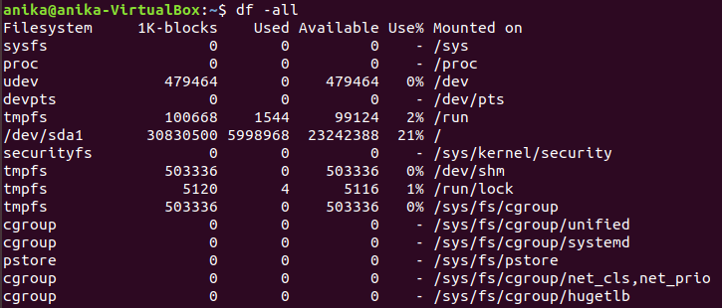

1. du: du command is used to show disk space usage of files present in a directory as well as its sub – directories .

Example :

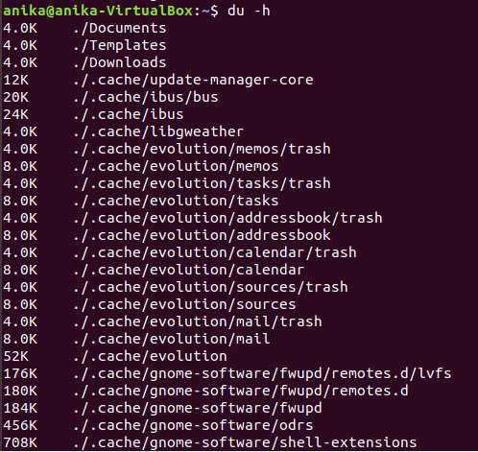

1. mkdir :mkdir command is used to create single or more directories, if they do not already exist (this can be overridden with the –p option).

Example :

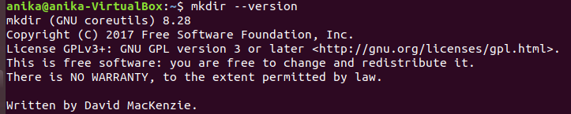

1. passwd :passwd command is used to create or update passwords for user accounts, it can also change the account or associated password validity period.

Example :

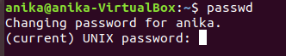

1. rm :rm command is used to remove files or directories .

Example :

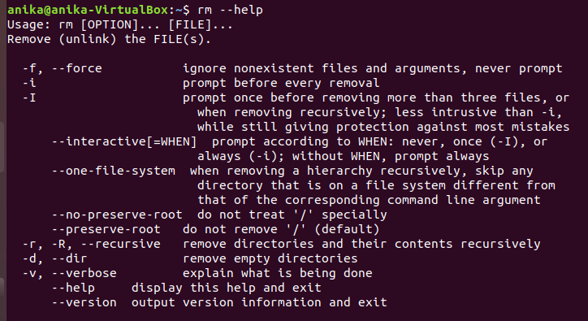

1. ln : ln command is used to create a soft link between files using the –s flag .

Example :

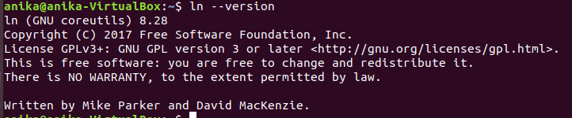

1. tar : tar command is a most powerful utility for archiving files in Linux.

Example :

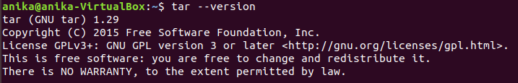

1. cd : cd stands for change directory and it does the same as it name stands for.

Example :

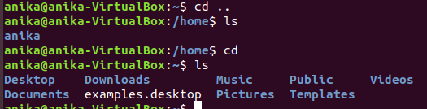

1. bzip2 : bzip2 command is used to compress or decompress files.

Example :

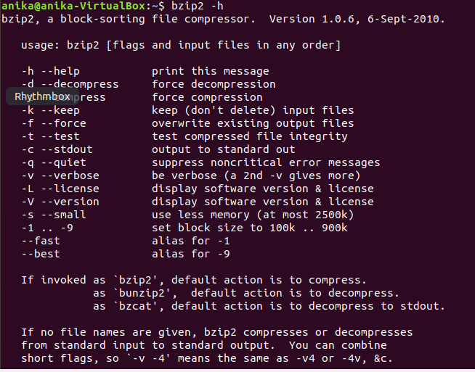

**13. nano, vi, jed — nano** and **vi** are already installed text editors in the Linux command line. The **nano** command is a good text editor that denotes keywords with color and can recognize most languages. And **vi** is simpler than **nano**. You can create a new file or modify a file using this editor. For example, if you need to make a new file named **"check.txt**", you can create it by using the command “**nano check.txt**”. You can save your files after editing by using the sequence Ctrl+X, then Y (or N for no). In my experience, using **nano**for HTML editing doesn't seem as good, because of its color, so I recommend **jed**text editor. We will come to installing packages soon.

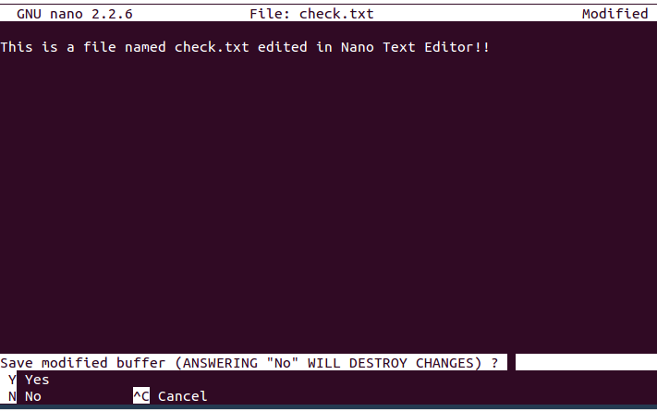

**14. sudo** — A widely used command in the Linux command line, **sudo** stands for "SuperUser Do". So, if you want any command to be done with administrative or root privileges, you can use the **sudo** command. For example, if you want to edit a file like **viz. alsa-base.conf**, which needs root permissions, you can use the command – **sudo nano alsa-base.conf**. You can enter the root command line using the command “**sudo bash**”, then type in your user password. You can also use the command “**su**” to do this, but you need to set a root password before that. For that, you can use the command “**sudo passwd**”(not misspelled, it is **passwd**). Then type in the new root password.

**15. du** — Use **du** to know the disk usage of a file in your system. If you want to know the disk usage for a particular folder or file in Linux, you can type in the command **df** and the name of the folder or file. For example, if you want to know the disk space used by the documents folder in Linux, you can use the command “**du Documents**”. You can also use the command “**ls -lah**” to view the file sizes of all the files in a folder.  
